**Performance Instructions for Sounds of Piano**

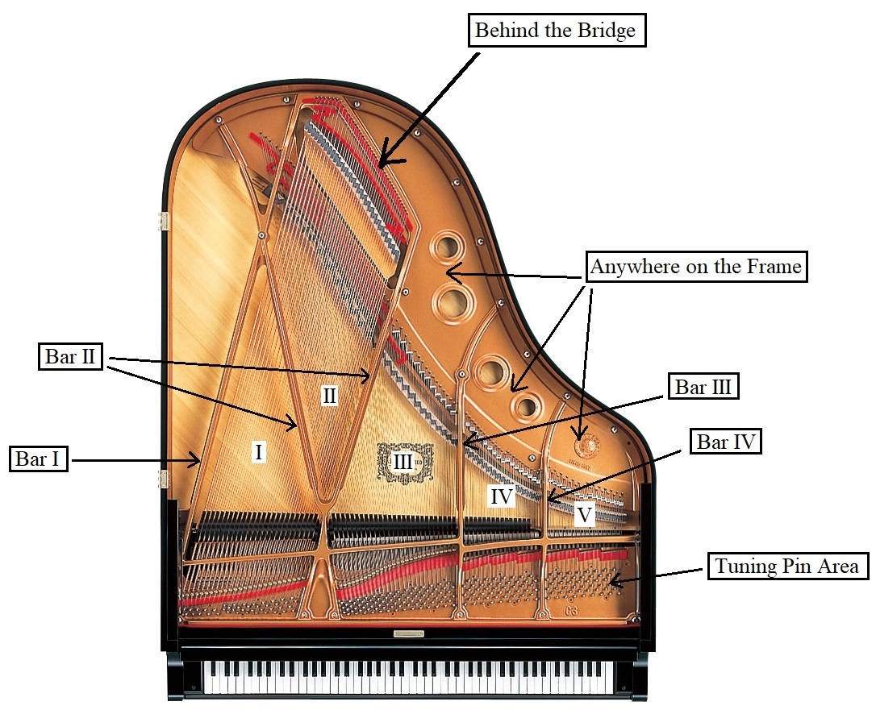

* This diagram above guides performers where they are required to play at.
* As every piano is different, the piece always starts labelling from the lowest bar and area as Bar I and Area I.
* Performers are required to follow the stopwatch while performing the work, as the timing is stated in the beginning of every system (10 seconds for each system).

***Suggestions on handshapes:***

* *Play without depressing keys*

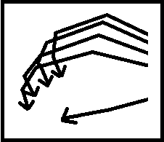

**=**

* *Damp strings with lower palms and twist palm*

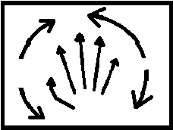

**=**

***Tools:***

* Mike Balter ERSR Mallets

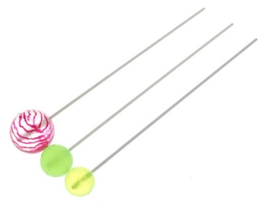

* Wooden Stick/ Mallet

